BLOG SCRIBE

MUSFIRA SHIRIN P

FEBINA SHERI.P

RASHIDA V

RAJIA KOLLENI ABDUL RASHEED

INTRODUCTION

Blogs are a new and intriguing form of communication and personal expression. Researchers are only just beginning to realize the value that these media present as sources of data for research. Individual expression has evolved into a new and useful form. Blogs have become an important form of emotional and informational release for a growing proportion of the population. Commencing with an overview of the development of the blog. Inscribe is the practice of making the best ideas, the most obvious...Publish your passion in your own way...through this platform we provide an opportunity that each and every one to express their thoughts and feelings on some topic

**Frontend used**

1. html
2. css
3. Bootstrap

**Backend Used**

1. Django

**Database Used**

1. SQlite

**Requirments**

1. install python, Django, IDE
2. Create Virtual environment (py -m venv myproject- windows)
3. pip install Pillow
4. pip install django-ckeditor

**SCREENSHOTS**

1. **LOGIN PAGE**

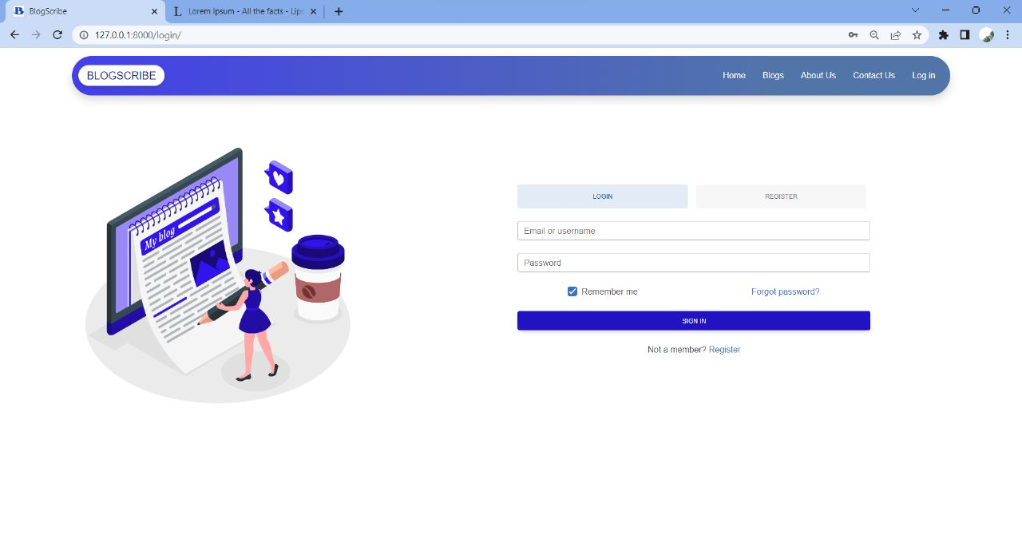

**SIGNUP PAGE**

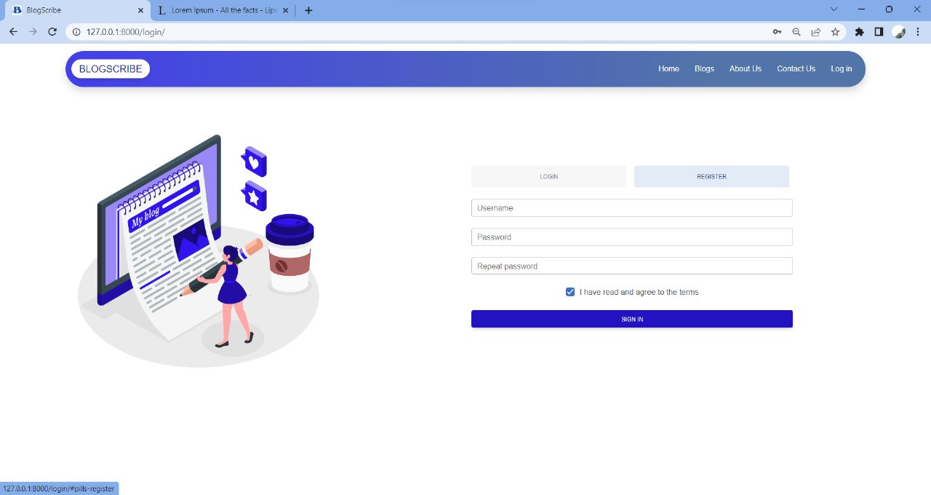

1. **HOME PAGE**

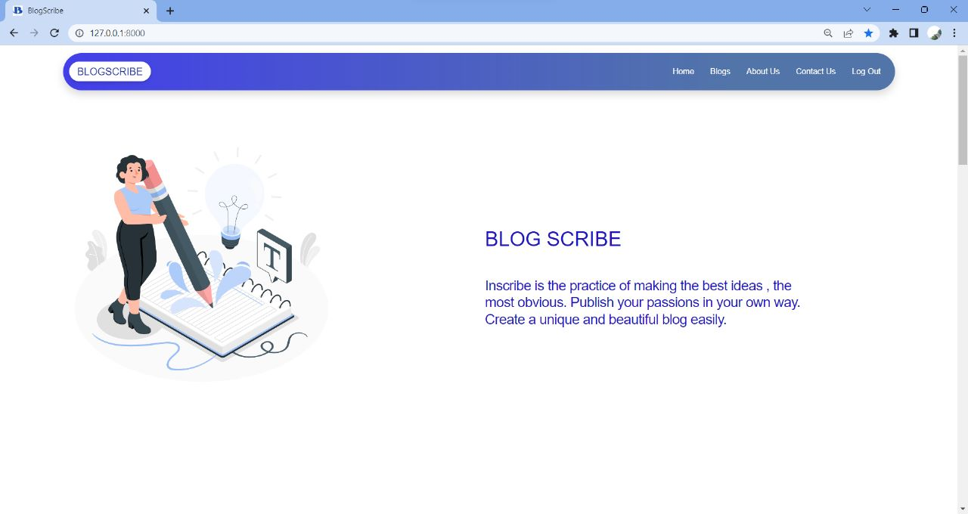

1. **LIST OF USER BLOGS**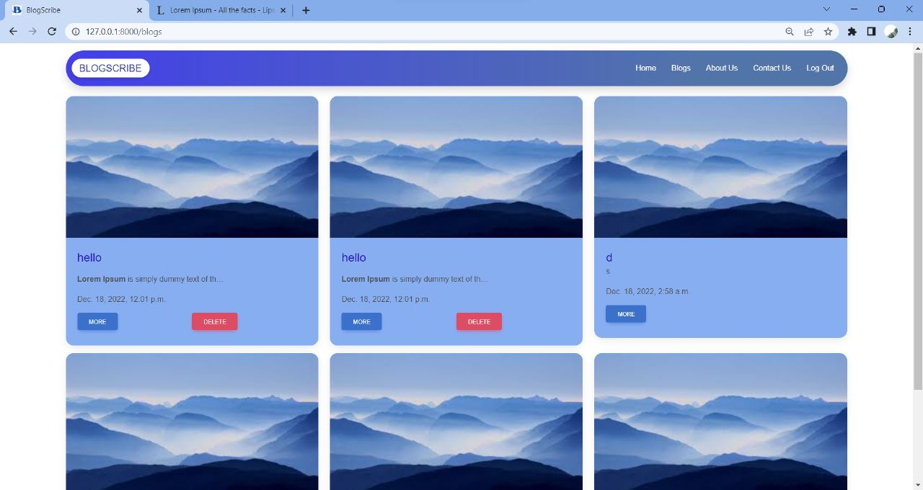

**4. CREATE A BLOG**

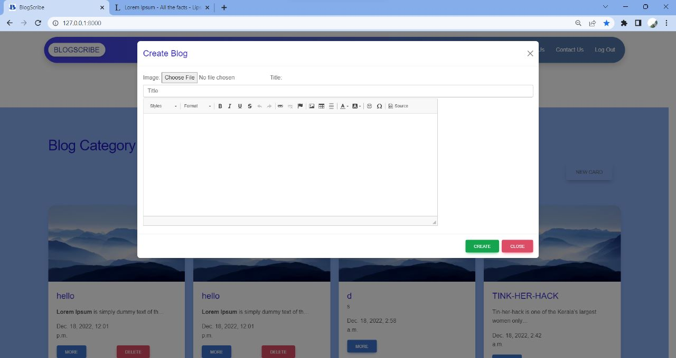

**5. DETAILED DESCRIPTION ON BLOG**

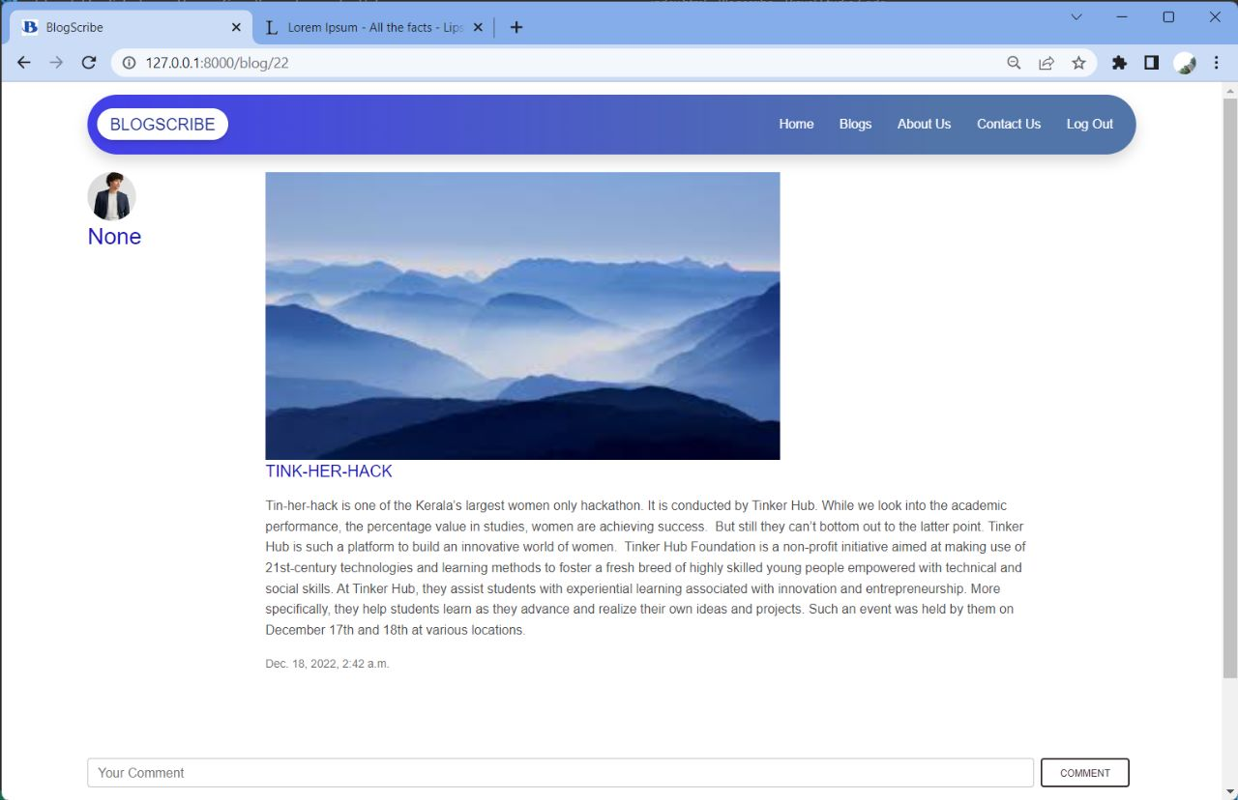

1. **ABOUT US**

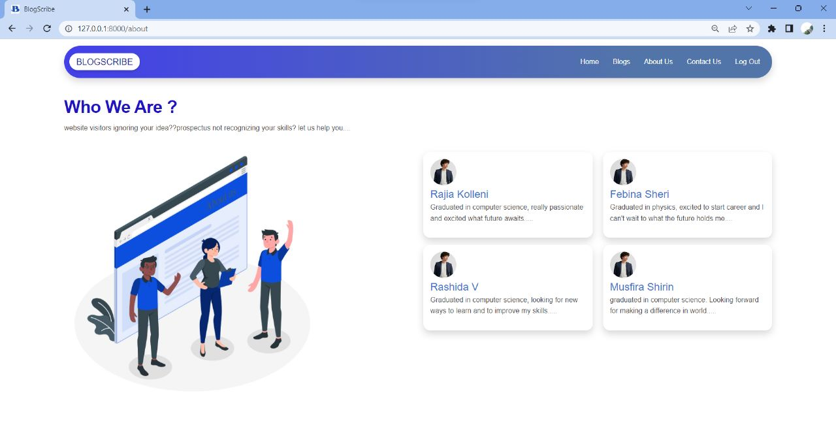

**8. CONTACT US**

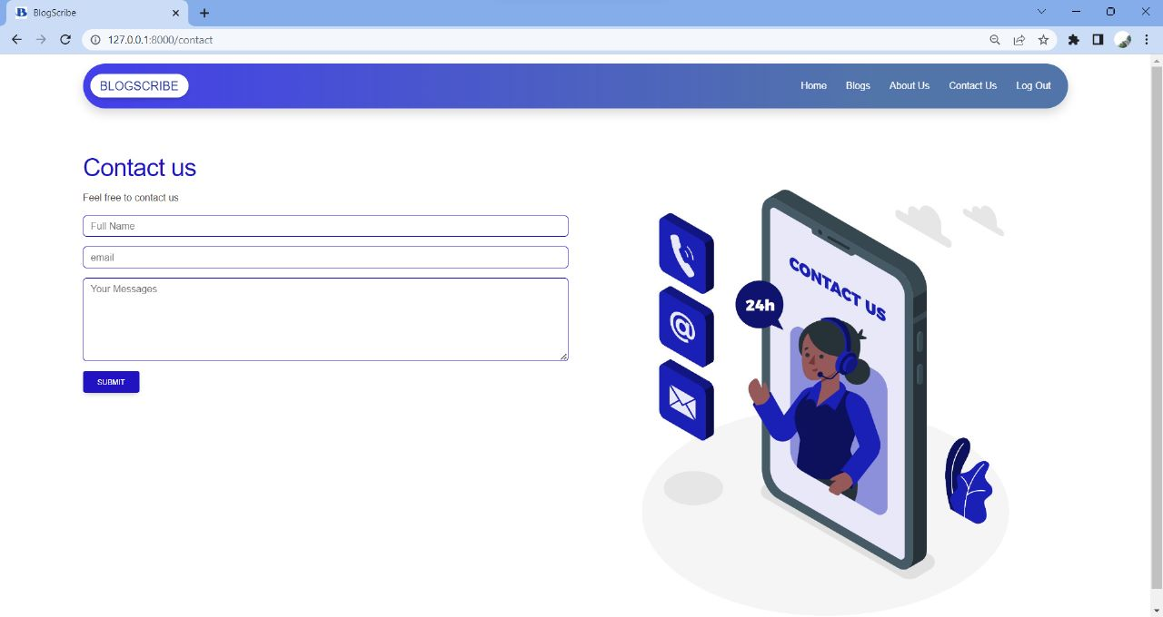

**REFERENCES**

* <https://www.w3schools.com/howto/howto_css_blog_layout.asp>
* <https://www.w3schools.com/django/index.php>
* <https://www.udemy.com/course/learning-python-for-data-analysis-and-visualization/>
* <https://www.figma.com/file/OtO4GWqYnTNtKF7qGAGe9Y/Untitled?node-id=0%3A1>